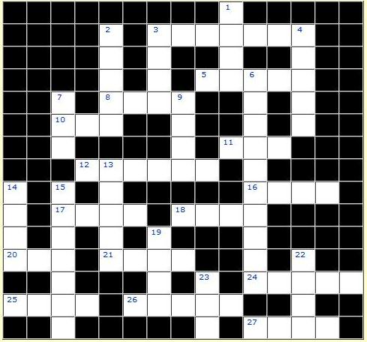

Crossword.
Write the second (II) and the third (III) forms of the verbs:

Across: 3. BRING (II) 5. STICK (II) 8. SING (II) 10. EAT (II) 11. FEED (II) 12. SHAKE (III) 16. SELL (III) 17. READ (III) 18.LEAVE (II) 20. MEET (II) 21. DRAW (II) 24. DRINK (II) 25. FLY (II) 26. STAND (III) 27. MAKE (III)

Down: 1. HURT(II) 2. CHOOSE (II) 3. BE (III) 4.TAKE (III) 6.UNDERSTAND (II) 7. SIT (II) 9. GO (III) 13. HEAR (II) 14. SWIM (III) 15. WRITE (III) 19. GO (II) 22. PAY (II) 23. WIN (II)

Crossword.
Write the second (II) and the third (III) forms of the verbs:
Across: 3. BRING (II) 5. STICK (II) 8. SING (II) 10. EAT (II) 11. FEED (II) 12. SHAKE (III) 16. SELL (III) 17. READ (III) 18.LEAVE (II) 20. MEET (II) 21. DRAW (II) 24. DRINK (II) 25. FLY (II) 26. STAND (III) 27. MAKE (III)

Down: 1. HURT(II) 2. CHOOSE (II) 3. BE (III) 4.TAKE (III) 6.UNDERSTAND (II) 7. SIT (II) 9. GO (III) 13. HEAR (II) 14. SWIM (III) 15. WRITE (III) 19. GO (II) 22. PAY (II) 23. WIN (II)

